**Project 1: Sales Insights**

**ABOUT THE PROJECT**

I analyzed and carried out a Sales analysis on a fictional organization dataset provided by CodeBasics.IO

**TOOLS USED**

MySQL

Tableau

**DATASET OVERVIEW**

Wayne Enterprises is a computer hardware and peripherals manufacturer and seller. The Manager Head of Sales working at the head office wants to find out some key insights regarding declining sales based on four years of data.

**DATA PREPARATION**

I downloaded a copy of the dataset from the codebasics.io website. Once done, I created a copy of the original SQL file and explored the dataset.

I needed to answer the following business questions:

1. What is the year-by-year trend for Revenue – upward or declining?
2. Who’re the Top 5 customers and products
3. Bottom 5 markets (for the purpose of designing a new strategy for growth)
4. Finding out the Profit margin by Market and by year
5. List of customers by Profit and Profit margin %

Once done exploring the data, I connected the data source with Tableau for generating key insights.

**DATA CLEANING**

1. Filtered-out columns having negative and NULL values in Sales Amount.
2. Filtered out a few foreign markets which were not currently operational.
3. A few records were having currency as USD (instead of INR), therefore, normalized the values by multiplying it with the prevalent exchange value.

**DATA ANALYSIS**

To analyze the data in the Tableau desktop, I created a few calculated fields to enrich my analysis (e.g.: Profit margin%)

The results of the analysis are shown in the report and seek to answer the aforementioned business questions.

**FINDINGS**

1. Year-by-Year trend for revenue is declining (Seeing a high of about 116M in the first quarter of 2018, the revenue has declined by 50%, coming to 63M in Q2 of 2020).
2. Top 5 Customers and products are as follows:

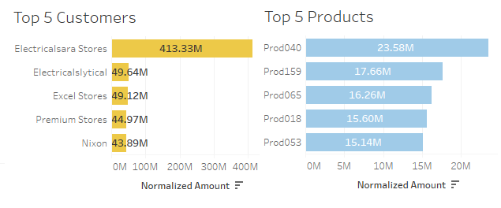

1. Bottom 5 markets (overall) by Revenue are Bengaluru, Bhubaneswar, Surat, Lucknow, and Patna. By Sales quantity, Bengaluru, Patna, Bhubaneswar, Kanpur, and Surat.
2. Highest Profit margin (overall) for any city: Surat 4.86% and lowest: Bengaluru -20.78%. Profit Margin by Year: 2017 - 2.98%, 2018 – 2.26%, 2019 – 3.12%, 2020 – 1.45%.
3. List of top customers by Profit and Profit margin %

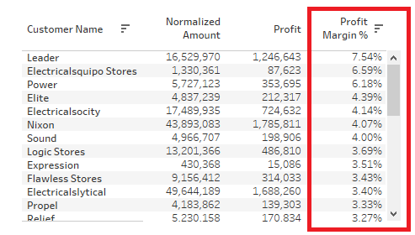

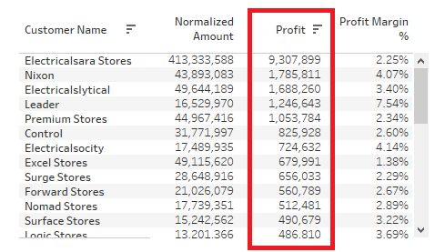

**RECOMMENDATIONS**

Based on my findings, I would recommend that Wayne Enterprises:

1. Conduct research to understand what your customers want and what they are willing to pay for. By doing this, sales and revenue can be drastically improved in poorly performing markets such as Bengaluru.
2. Develop a marketing plan that reaches your target customers and use analytics to track your marketing efforts and adjust your strategies based on the results.
3. Expand your product or service line by offering complimentary services.
4. Implement pricing strategies: Price your products or services based on market demand, competition, and the value you provide to your customers.
5. Reduce costs: Look for ways to reduce your costs without sacrificing quality.

Consider negotiating better prices with your suppliers, reducing your inventory levels, or automating your processes to reduce labor costs.